Sean Blanchard

4/6/2021

COMP420 HW 3

***Interfacing with the data***

You have 6 different options when running the program, 1 to insert or create a new record, 2 to Search a Record, 3 Update a Record, 4 Delete a Record, 5 Make a Report and 6 Close Program Gracefully.

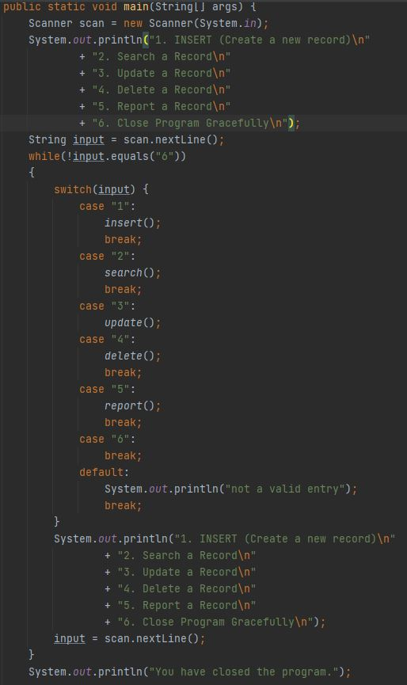

This code will help direct the user to functions that perform different tasks. Lets say a user wants to insert into the database, they would hit 1.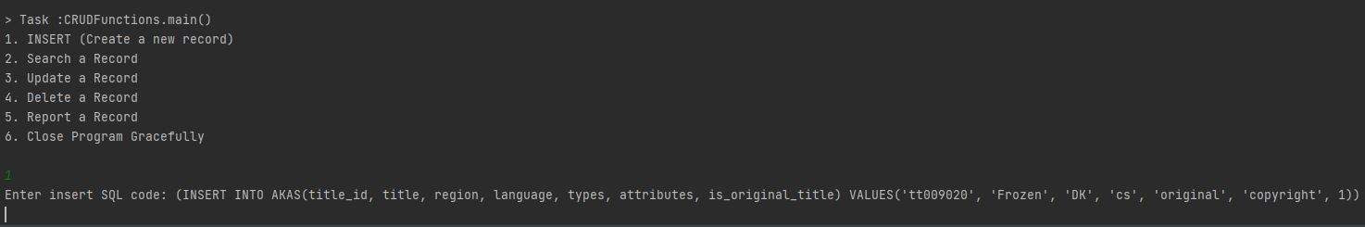

After writing a correct Insert SQL statement, you can see that it connects to the MySQL Server. After that It inserts the values into AKAS.



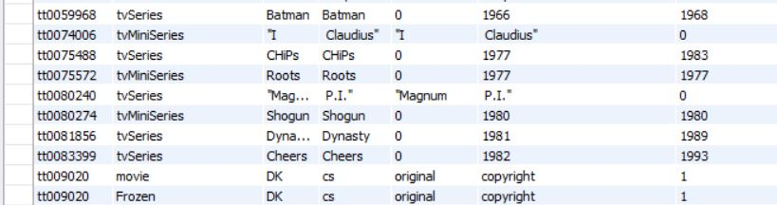

If the user wants to search the database, they will press 2.

After writing a correct SELECT SQL statement, you can see that it connects to the MySQL Server. After that it selects the values from AKAS table and displays the values selected.

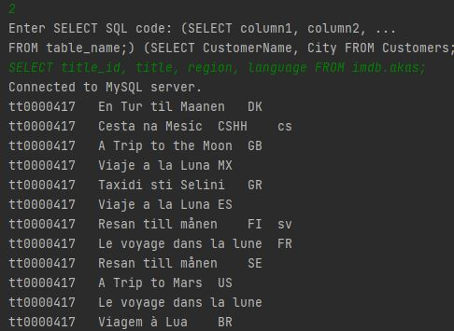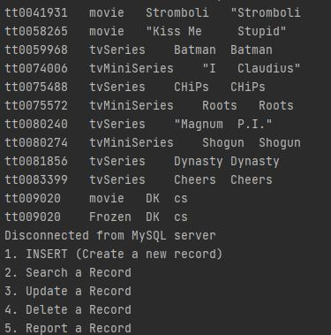

If the user wants to update the database, they will press 3.

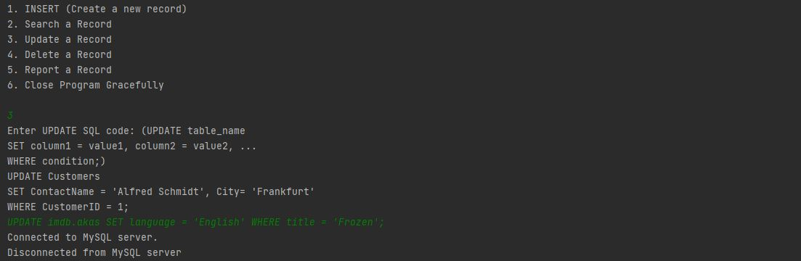

After writing a correct UPDATE SQL statement, you can see that it connects to the MySQL Server. After that it UPDATES the values from AKAS table.



If the user wants to delete from the database, they will press 4.



After writing a correct DELETE SQL statement, you can see that it connects to the MySQL Server. After that it DELETES the values from AKAS table.



If the user wants to SELECT from the database, giving them the title_id by passing in a title, they will press 5.

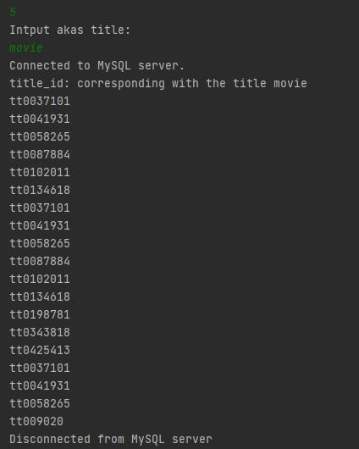

If the user wants to quit the CRUD Functions, they will press 6